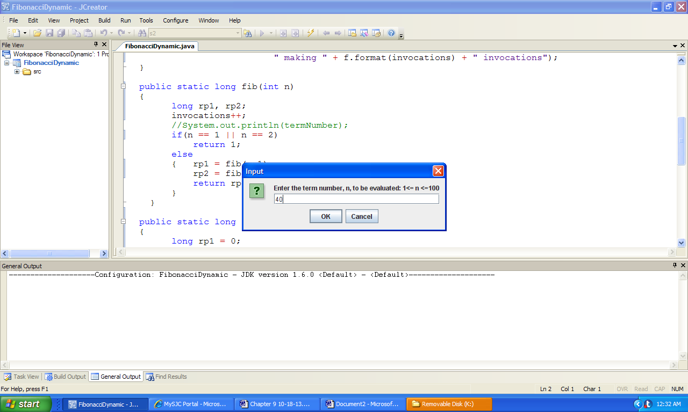

***Console output:***

fn = 102,334,155

calculated making 204,668,309 invocations

fn = 102,334,155

calculated making 40 invocations

**Figure 9.21 Output of FibonacciDynamic.**